**Preoperative planning simulator with haptic feedback for Raven-II surgical robotics platform**

**Akshay Bhardwaj, Aarshay Jain, Vijyant Agarwal**

Manufacturing Processes and Automation Engineering

Netaji Subhas Institute of Technology, University of Delhi

Delhi 110078, India

Email:{akshay.bhardwaj1102, aarshay.jain, vijaynt.agarwal}@gmail.com

*Abstract* - In this research we present a Preoperative Robotic Surgery Simulator platform as a means of training for Raven-II Surgical system. The simulator employs PHANTOM Omni (now Geomagic® Touch™) as a master device to control the arms of the 3D simulated model of Raven-II in virtual environment. The earlier simulators for Raven-II were built primarily to work over Debian-based Linux Operating Systems. This is the first attempt towards development of a simulator in MATLAB which, being a cross platform application, allows the accessibility of the simulator to a broader community of surgeons and researchers. In terms of features, the simulator is designed to provide the haptic feedback to the user which results in even more realistic emulation of surgery environment. Other features of the simulator include opening and closing of the surgical tool using pen buttons of PHANTOM Omni and a ‘freeflow’ feature with which a surgeon can willingly pause the surgical procedure anytime while conducting operation. The simulator was successfully built and tested in MATLAB and the results from the simulation satisfactorily verified the efficacy of the proposed system.

Keywords— Robotic Surgery; Preoperative setup planning; Raven-II; Robot setup simulation

# Introduction

Surgical robotics essentially promote the laparoscopic operation through minimally invasive surgery (MIS). It is a type of surgical operation in which the surgeon inserts surgical instruments inside patient’s body through small incisions which is a particularly tough job. Nonetheless, the arrival of robotics, both in MIS and in open surgery has increased the use of minimally invasive surgery among inexperienced surgeons and has enabled experienced surgeons to include more complex reconstructions in surgery [1]. The potential benefits of minimally invasive or robotic surgery are shorter recovery time, lower risk of pain, tissue trauma and infection, lower blood loss and improved cosmesis [2,3,4,13].

However, providing surgical training directly on the robot has some serious drawbacks. Firstly, due to the inherent complexity of surgical robots, there is always some risk associated with training an unskilled surgeon in basic surgery skills directly on a human subject [6]. Furthermore, the cost of operating surgical robots is usually very high. For instance, robotic parts may easily become unusable by misuse (or overuse) by trainees necessitating additional funds for their repair and maintenance [3]. Besides, for training, the availability of surgical machine and the working hours with the robot are very limited [6, 2]. Hence, it might oftentimes take years of training to perfect robotic surgery procedures [4].

Consequently, surgical simulators are nowadays gaining huge importance in medical and health professional education because they overcome all the above mentioned training limitations for robotic surgery. Simulators have an ability to provide safe, cost effective and realistic surgical training environment. Moreover, with further developments in computer technology and real time capabilities, it has become relatively easier to emulate the actual surgical procedure.

Simulators help in building up the essential skills for independent operation on the robots. However, their role lies alongside traditional training [2]. Hence, even after complete training with a reliable simulator, working on an actual robot will need additional work on the robot. But the time and skills needed to perfect the procedure will certainly be significantly lesser than before.

Today, substantial research and development has been devoted to development of the virtual reality simulators so that the naïve surgeons may enhance their medical skills in a controlled and a similar surgical environment, prior to live patient interaction, thereby improving patient safety.

This paper presents a virtual reality simulator for the Raven II surgical robot which is an open source research platform in surgical robotics. For the surgeon interface, the PHANTOM Omni (now Geomagic Touch™) haptic device has been used as the master device to provide the haptic feedback.

Raven IITM is a research platform [8] that is helping the open source community advance state of the art in surgical robotics. This system is primarily developed to broach the opportunities for a new collaborative surgical robotics research using the common Raven-II platform.

The PHANTOM Omni Bundle is a 6 DOF haptic device. This device makes it possible for users to perceive and manipulate virtual objects. It is cost-effective and provides a safe way to implement intermediate and advanced control concepts and theories related to robotics and haptics. In this research the PHANTOM Omni haptic device has been integrated with QUARC® control software for designing the simulator.

# Literature Review

The existing literature primarily reviews the development of medical simulators and current surgical simulators being employed in Da Vinci Surgical Systems and exemplifies the different types of input haptic devices, manipulators and simulator training modules being employed.

In a review done by Abboudi et. Al [2], the current chief commercial simulators were identified as *Robotic Surgical Simulator* (RoSS ®), *Simsurgery Educational Platform* (SEP), *ProMIS* ®, *Mimic dV-Trainer* (MdVT) *Da Vinci Skills Simulator* ®, *University of Nebraska* simulator. The simulators’ implementation in the initial phase of training was validated. The high costs of these commercial simulators were stated and it was found that with the ever increasing market competition between the different simulator manufacturers, the cost of the simulators may decrease in the near future. It was concluded that they hold great potential and responsibility in the 21st century.

Jianxin Sun et al [3] developed and tested a novel design of effector for high level operating standard such as da Vinci robotic system. The effector was combined to Omni device employed to provide position information for robotic training for da Vinci surgical system in virtual environment [3].

Hesselbacher et al designed a laparoscopic manipulator with haptics force feedback to provide an artificial sense of touch [4]. A biocompatible sheath was also employed to shield the manipulator to enable the manipulator suitable to be used for up to 200 surgeries [4].

Brian et al conducted a study to substantiate the fact that visual sensory substitution permits the surgeon to apply more consistent, precise, and greater tensions to fine suture materials without breakage during robot-assisted knot tying [5].

The review done by C.D Combs [6] supplements the research with a detailed assessment of the newest simulation products, their current applications in medical and health profession education and the remaining needs that are yet to be addressed. In his comprehensive study on medical simulators, four mannequin simulators were also mentioned [6].

Zohaib et al carried out a comparative study of input devices for virtual surgery simulations [7]. The need for input devices for effective and real simulator design was elaborated. They trained a group of users on virtual exercises with different input devices like mouse, joystick and force feedback joystick, Omni and a custom-built laparoscopic hand manipulator.

Mehmet et al focused on configuring a new robot structure to be used in haptic systems that could introduce some improvements over traditional haptic systems [9].

Ali et al [10] employed a robotic hand-held instrument with jointed effectors, RealHandTM, that was believed to be helpful to suture in angles that was impossible using a conventional instrument. Some advantages of a robotic instrument such as facility of implementing different control modes, the easy implementation of locking mechanism for more precise gestures and the facility to amplify hand movements were highlighted.

Katsunori and Yoshioro proposed a prototype to a surgical simulation system that provided intuitive operation using a Phantom device [11]. The prototype, along with providing intuitive operations, supported COLLADA-based file format that included ‘haptic materials’ and annotation information besides standard 3D geometry data, their materials and animation data [11].

Ankur et al [12] discussed mapping between Robot Surgical Simulator (RoSS) and Da Vinci surgical System’s (DVSS’s) master and preliminary skill training modules. A full working prototype virtual trainer was reported for DVSS. The trainer included articulated linkages which replicated the movements of the manipulator.

In the review done by S. Giri and D.K. Sarkar [13], current status of robotic technology in surgery was elucidated. The growing rate of importance of Da Vinci surgical system was exemplified. Besides, the most important drawbacks of the Da Vinci Surgical Systems such as its long setup times, longer operation times and high costs were also mentioned. To prove the considerably higher costs of robotic systems over conventional open surgery, several cost analyses were also revealed. Finally, it was concluded that using trained personnel can lower setup and operation times.

Through the review, we learnt about the various types of surgical simulators and input devices, manipulators and software employed in these along with their present challenges. Accordingly, we found out that no efforts have been put in the development of surgical simulators for Raven-II platform with haptic feedback on cross platforms applications like MATLAB. This essentially formed the basis of our work.

# Methodology

## 3D Simulator Design

The basic steps involved in developing the 3D QuaRC (Quanser) visualization are depicted & enlisted below.



Fig. 1. Steps involved in designing the 3D visualization

The various steps involved are:

1. Solid models of individual constituent parts of Raven IITM robot viz. base, link 1 and link 2 were constructed on the Solidworks software using the Raven-II DH parameters.
2. Each solid part constructed was later saved as an assembly part.
3. STL files of individual parts were exported from the assembly part using Solidworks SimMechanics Link plugin which were then converted into x3d file format required for visualization in QUARC using MESHLAB.
4. The x3d files created were then imported into the QUARC visualization block in the form of meshes.
5. Next, the meshes were assembled by giving suitable translation and orientation values to place the center of each link at the appropriate position with the correct orientation.

The 3D CAD model was made fully conforming to the Raven-II DH parameters.

## Simulink modeling for implementation of simulator

The simulink diagram shown in Figure A.1 (appendix) was made to implement the simulator. This figure contains symmetric blocks for the left and right Raven-II robots. To describe the simulator only the right robot is discussed. The left robot will work in a similar fashion.

The simulink block diagram represents implementation of the pre-operative planning and assessment simulator. The stepwise flow of information is as follows:

**Step 1.** Q123R is phantom desired joint angle positions for joints 1, 2 and 3 coming from differential input in this block. Q4567R is for joints 4,5,6 and 7.

**Step 2.** Data is read from the Phantom Omni Bundle Haptic Device in form of end-effector position, the gimbal angles and the button status. This is done in Subsystem block.

**Step 3.** The position values are fed into another subsystem titled "Calculation of Changes in Positions in each dimension". This determines the change in position of the surgeon’s hands in all dimensions and feeds it into the switch.

**Step 4.** The switch here implements the ‘freeflow’ feature, i.e. if the surgeon wants to move his hands freely without moving the robot, then he can press both the switches on the phantom device and the connection between robot and surgeon is paused for this period. This prevents the surgeon from being bound to continuously work in ergonomically undesirable positions as with this feature present, he can re-adjust at his will without moving the robot. The switch is implemented as following:

If button>= 3; pass [000] as the change in position (signifying no change) else pass the original values of surgeons hands

**Step 5.** These position change values are fed into the subsystem titled "Calculation of Changes in Joint Angles of Simulated Raven in each dimension". This block determines the joint angles of the robot required to mimic the surgeon’s motion.

**Step 6**. The "Phantom Gimbal Angles to Raven Wrist Angles" subsystem controls the robot's wrists using the buttons input and the phantom gimbal angles. This block contains a novel algorithm to map the surgeon's motion into robot.

**Step 7**. The "End-Effector Jaw Motion Control Algorithm" block implements a latching mechanism which implements opening and closing of robot's jaws using the buttons input. The code implements following algorithm:

If button >= 3; do nothing (because *freeflow* will be activated at that moment)

else if button >= 2; close the jaw by 1 degree

else if button >= 1; open the jaw by 1 degree

**Step 8**. The "Visualization Initialize" block contains the entire simulation formed by importing CAD models into MATLAB, which were detailed earlier. The "Visualization Set Variables" block is used to give the motion commands to simulation in terms of translations and rotations of the coordinate axes of various elements present in the simulator.

The detailed functioning of each subsystem is given below:

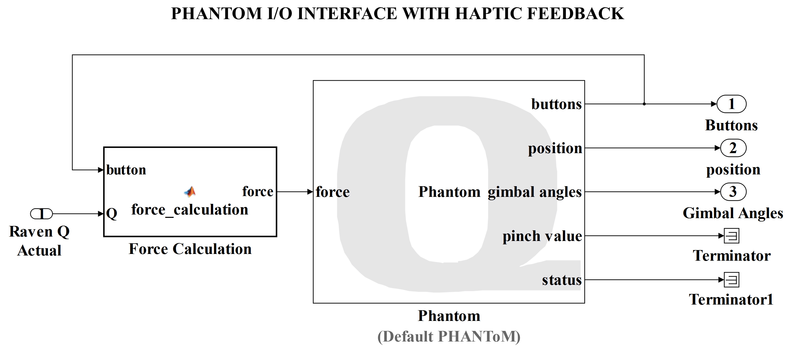

Fig. 2. Phantom I/O Interfacing and Haptic Feedback

Two things are simultaneously happening here:

1. Phantom block from the QUARC toolbox is used to interface with the hardware and read the end-effector position and wrist (gimbal) angles. These are directly sent forward.
2. Haptic force that the surgeon should feel is calculated in the self-defined MATLAB function titled "force calculation". This block takes the current position of the robot and estimates the interactions with the environment to calculate the haptic feedback forces.

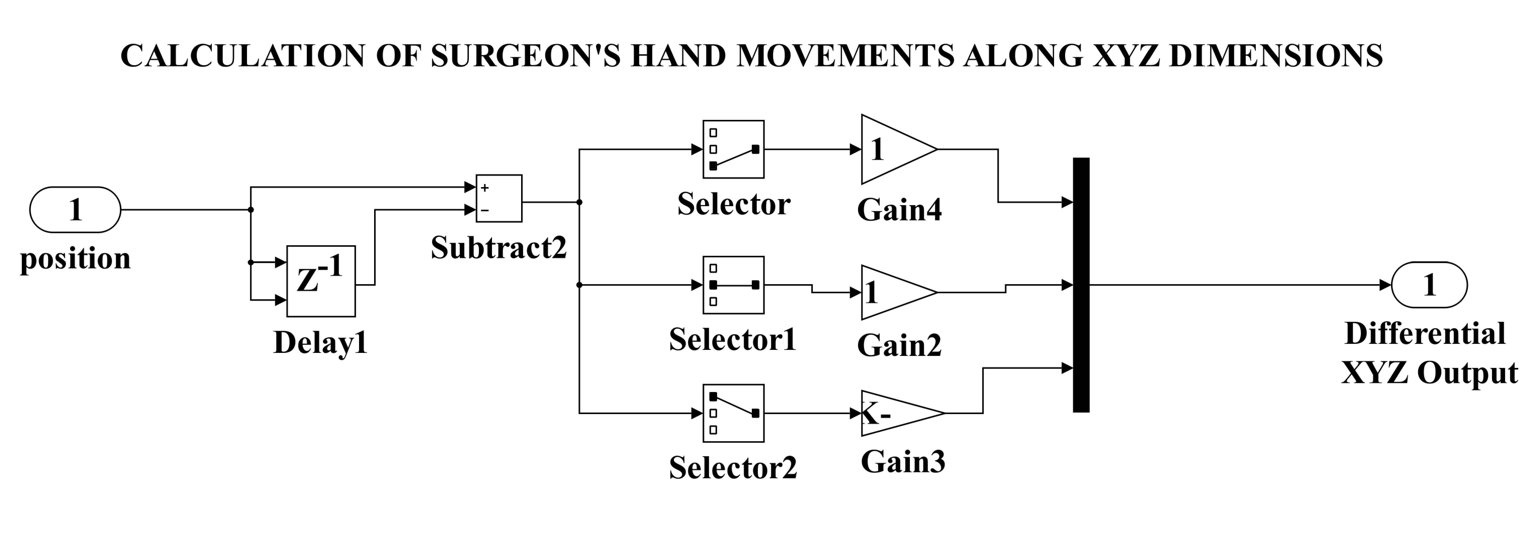

Fig. 3. Calculation of Surgeon's Hand Movements along XYZ Dimensions.

This block caters to two requirements:

1. Calculates the change in position by subtracting the current value from the previous value. It allows an additional feature of multiplying each gain by a factor which allows scaling of the surgeon's motion. A scaling factor of 1.25 is used in motion in Z dimension, rest are 1.
2. It converts the phantom Cartesian frame to the robot Cartesian frame. This is done using following relation: Raven Robot[x y z] = Phantom[z y -x]

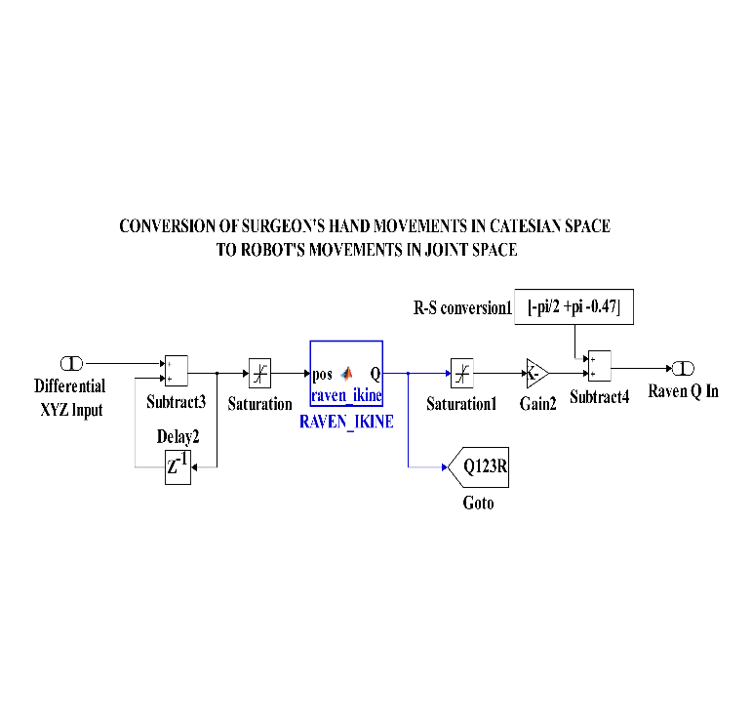

Fig. 4. Conversion of Surgeon's XYZ movement to robot's joint angles

This block caters to the following requirements:

* The differential input is added to the previous position to get the new reference position of the robot.
* The saturator block used here prevents the reference position from going beyond the workspace of the robot. If this happens, then a real solution will not be obtained and the simulation will seize to function.
* The raven *ikine* block implements the analytical inverse kinematics solution of the Raven-II surgical robot.
* The second saturator block allows application of mechanical constraints in the joint space of the Raven robot.
* The gain and subtract blocks enable conversion of the actual Raven joint space into the simulated Raven joint space. This is necessary to cater to any coordinate shifts that occur in the process of importing and converting documents.

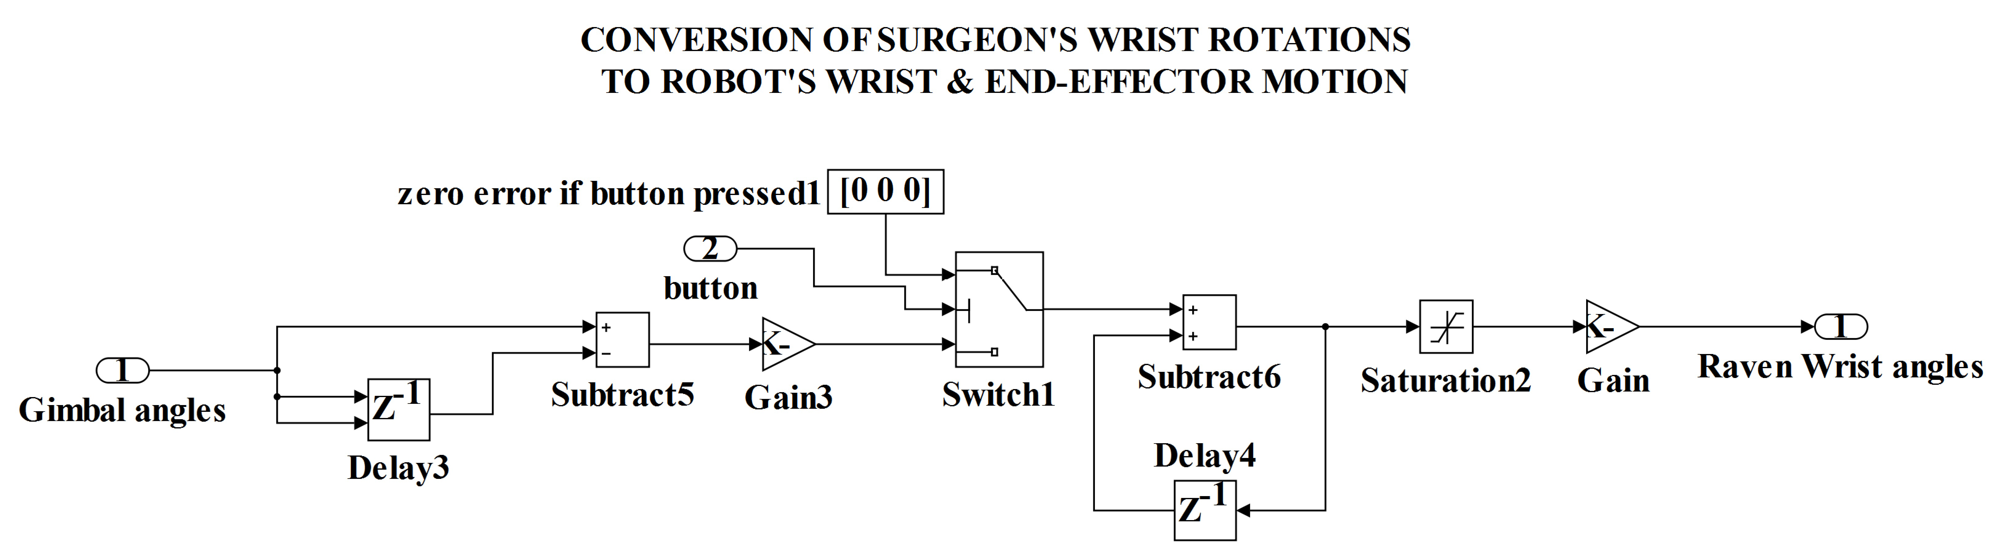

Fig. 5. Conversion of Surgeon's Wrist Rotations to Robot's Wrist Angles

This block caters to following requirements:

* Change in gimbal angles are calculated by subtracting from the previous instant's value.
* The Gain block allows setting multipliers for each of wrist motion. This parameter was adjusted to give maximum comfort to surgeon and avoid fatigue.
* The switch implements the "freeflow" feature of the simulator. This prevents the surgeon from reaching awkward positions as he can re-adjust at his will without moving the robot. The switch is implemented as follows:

if button >= 3; pass [0 0 0] as the change in position signifying no change else pass the original values of surgeons hands

* The amount of change to be induced is then added to the previous instant's values to get the new wrist position reference values.
* The saturator is used to implement mechanical constraints.
* The gain block is used to convert the values into a positive rotation convention of the simulation.

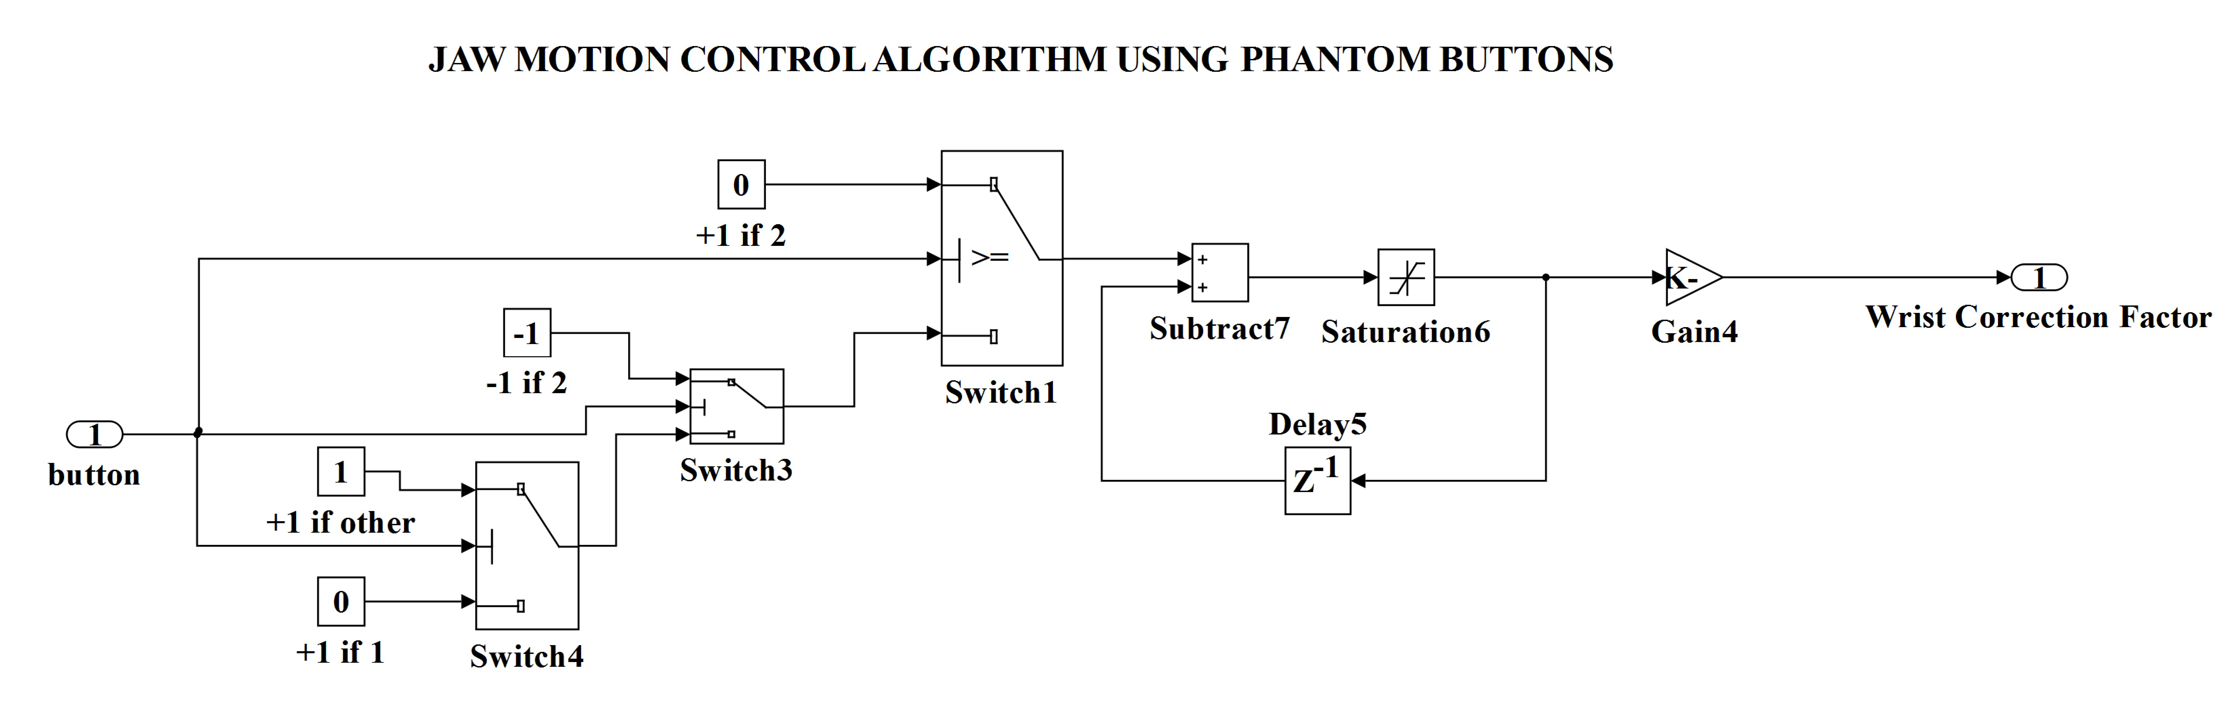

Fig. 6. Calculation of Surgeon's Hand Movements along XYZ Dimensions

This block caters to following requirements:

* This block controls the movement of the end-effector jaws, i.e. the Q6 and Q7 joint angles, using buttons on phantom device.
* It calculates the Wrist Correction Factor which modifies the Q6 and Q7 joint angle values to enable opening and closing of the wrist.
* The algorithm for determining the wrist correction factor (WCF) requires determining multiplier α as:

if button >= 3 then α = 0

else if button >= 2 then α = -1

else if button >= 1 then α = 1

else α = 0;

* Another important aspect is to latch the value of WCF. Once the button is released, the button value becomes zero but the wrist has to remain open, same is the case with closing. Thus, a latching mechanism is designed by simply adding the previous value of WCF so that it gets updated and not re-assigned every time.
* The gain block is used to nullify the effect of small sample time. A small sample time will give a large value of WCF even if button pressed for a small duration. Thus a gain of 0.5 is used to prevent very rapid opening and closing of jaws.
* The final value of WCF is given as WCF = α * (Duration of button press/sample time) * gain;
* The jaw motion is obtained by updating the Q6 and Q7 as Q6 = Q6 + WCF and Q7 = Q7 – WCF

# Result

The visualization model and the haptic feedback was validated using a patient and a heart model. The views of the models in both the cases are presented in Figure A.2 (Appendix). Although, heart is not a favored place for robotic surgery, the heart model was chosen because generally surgery is done in specific organs and the purpose of model is to develop a haptic feedback enabled system which gets satisfactorily fulfilled here.

# Conclusion

The earlier simulators for Raven II were based on Debian-based Linux Operating Systems. We have tried to develop this simulator in MATLAB which is a cross platform application and thus allows the accessibility of the simulator to a wider community of surgeons and researchers. The Preoperative Robotic SurgerySimulator was developed and validated with following features:

* Haptic Feedback to allow the surgeon to feel the tactile forces
* ‘Freeflow’ feature to maximize surgeon comfort by minimizing surgeon fatigue.
* Successful Control of 6 DOF of the Raven-II robot along with additional jaw opening and closing using the Phantom Robot which is 6 DOF device.

We now look forward to integrate more intricate and complex surgical tasks with our model that are intrinsic to cardiac surgeries. For that we will develop more real world models of the patient and heart to exactly emulate the actual surgical procedure. The simulator will thus be enhanced to become more conducive to real world training practices. We will then do statistical evaluation and validation of this system so that it can be brought to a level where it can be used for commercial purposes.

# Acknowledgment

We thank Dr. Arvind Kumar for supporting the development of this simulator and allowing us to witness live robotic surgery at Sir Ganga Ram Hospital that has immensely helped us in development of this simulator.

##### References

1. Jaydeep H Palep,"Robotic assisted minimally invasive surgery", *Journal of Minimal Access Surgery*, Vol. 5, no. 1, pp. 1-7, Jan-Mar 2009.
2. Hamid Abboudi , Mohammed S. Khan , Omar Aboumarzouk , Khurshid A. Guru , Ben Challacombe, Prokar Dasgupta and Kamran Ahmed, "Current status of validation for robotic surgery simulators – a systematic review", *BJU International*, 2012.
3. Jianxin Sun, Song Ci, Jung-Hung Chien, Shi-Hyun Park, Irene H. Suh, Dmitry Oleynikov, Ka-Shun Siu, "Innovative effector design for simulation training in robotic surgery", *3rd International Conference on Biomedical Engineering and Informatics*, IEEE, 2010.
4. E. Hesselbacher, A. Kilayko, M. Russell, and J. Varbanov, "Laparoscopic Manipulator with Haptics Force Feedback ", *Bioengineering Conference (NEBEC), 2012 38th Annual Northeast*. IEEE, 2012.
5. Brian T. Bethea, Allison M. Okmura Masaya Kitagawa Torin P. Fitton, Stephen M. Cattaneo, Vincent L. Gott, William A. Baumgartner and David D. Yuh, "Application of Haptic Feedback to Robotic Surgery", *Journal of Laparoendoscopic Advanced Surgical Techniques*, Vol. 14, No. 3, pp. 191–195, June 2004.
6. C. Donald Combs, "Medical Simulators: Current Status and Future Needs", *Workshops on Enabling Technologies: Infrastructure for Collaborative Enterprises*, 2010.
7. Zohaib Amjad Khan, Shamyl Bin Mansoor, Malik Anas Ahmad, Muhammad Muddassir Malik, "Input Devices for Virtual Surgical Simulations: A Comparative Study", IEEE, 2013.
8. Blake Hannaford, Jacob Rosen, Diana W. Friedman, Hawkeye King, Phillip Roan, Lei Cheng, Daniel Glozman, Ji Ma, Sina Nia Kosari and Lee White, "Raven-II: An Open Platform for Surgical Robotics Research", *IEEE Transactions on Biomedical Engineering*, Vol. 60, No. 4, April 2013.
9. Mehmet Ismet Can Dede, Özgün Selvi, Tunç Bilgincan, "Design of a Haptic Device for Teleoperation and Virtual Reality Systems", *Proceedings of the 2009 IEEE International Conference on Systems, Man, and Cybernetics* San Antonio, TX, USA - October 2009.
10. Ali Hassan Zahraee, Jerome Szewczyk and Guillaume Morel, "Evaluating Control Modes for Hand-Held Robotic Surgical Instrument Using Virtual Reality Simulator", *IEEE/ASME International Conference on Advanced Intelligent Mechatronics*, Singapore, July 14-17, 2009.
11. Katsunori Miyahara, Yoshihiro Okada, "A Surgical Simulation System supporting COLLADA-Based File Format", *Fifth International Conference on Computer Graphics, Imaging and Visualization,* IEEE, 2008.
12. Ankur Baheti, Sridhar Seshadri, Amrish Kumar, Govindarajan Srimathveeravalli, Thenkurussi Kesavadas, Khurshid Guru, "RoSS: Virtual Reality Robotic Surgical Simulator for the da Vinci Surgical System", *Symposium on Haptic Interfaces for Virtual Environments and Teleoperator Systems,* IEEE, 13-14 March, 2008.

[13] Subhasis Giri, Diptendra K. Sarkar, “Current Status of Robotic Surgery”, *Indian Journal of Surgery*, Springer, May-June, 2012.

##### Appendix

##### R:\BTP Thesis\COMPILE1.png

Fig. A.1 Pre-Operative Surgery Simulator- Both Robots

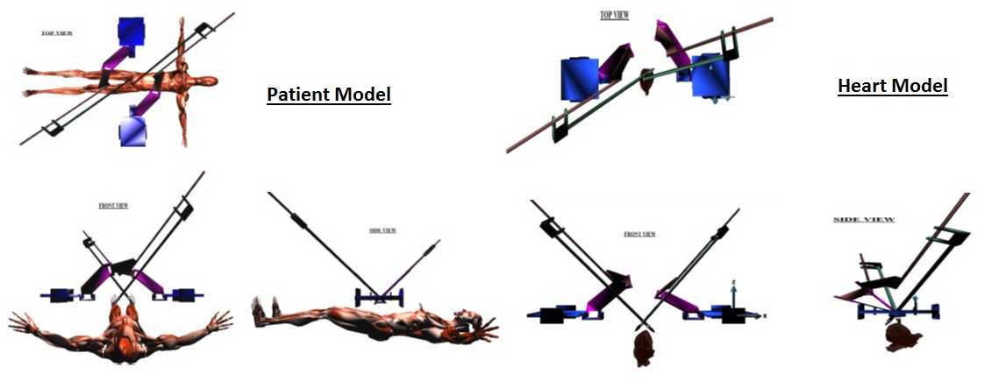

TOP VIEW

FRONT VIEW

TOP VIEW

FRONT VIEW

SIDE VIEW

SIDE VIEW

Fig. A.2 Patient and Heart Models as developed through Simulator